Constellations d’automne
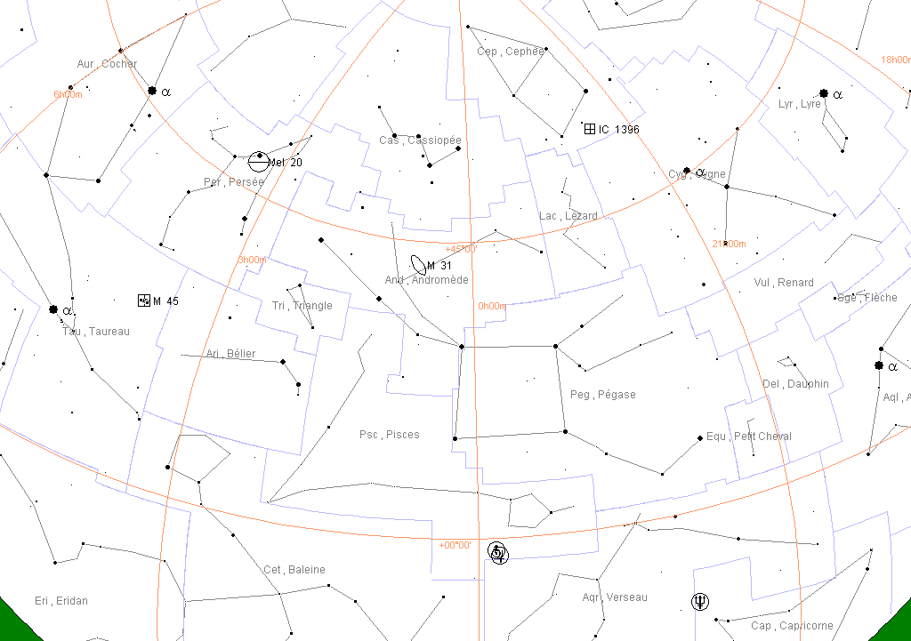
Etoiles repères :
Cygne | α Cyg | Deneb | 1.2 | 20h 41m | +45° 17'
(cygnus) | β Cyg | Albireo | 3-5 | 19h 31m | +27° 58'
Cassiopée | α Cas | Schedar | 2.2 | 00h 41m | +56° 33'
(cassiopeia) | β Cas | Caph | 2.2 | 00h 09m | +59° 10'
 | ε Cas |  | 3.3 | 01h55m | +63°43’
Pégaze  andromède | α Peg | Markab | 2.5 | 23h 05m | +15° 12'
 | ε Peg | Enif | 2.5 | 21h44m | +09°53’
(pegazus)
Andromède  pégaze | α And | Alpheratz | 2.1 | 00h 08m | +29° 06'
(Andromeda) | β And | Mirach | 2.1 | 01h 10m | +35° 38'
 | γ And | Almaak | 2.2 | 02h 04m | +42° 21'
Persée | α Per | Mirphak | 1.8 | 03h 24m | +49° 52'
(perseus) | β Per | Algol | 2 - 3 | 03h 08m | +40° 57'
Bélier (Aries) | α Ari |  | 2 | 02h08m | +23°31’
Céphée (cepheus) | α Cep |  | 2.5 | 21h19m | +62°38’

